STUDENT Joseph Roper

SALFORD CITY COLLEGE | FUTURE SKILLS

BTEC National Extended Diploma in Creative Media Production

UNIT 67: 3D ANIMATION

Unit 67 – 3D Animation

# Idea Generation

For my animation, I wanted to create a prison escape scene. In this scene, the inmate would escape by setting his bed on fire and by placing a fiery pillow under the running tap to create steam and smoke which will make the cell doors open as a safety feature while the smoke and fog will also act as a disguise and make it hard to see. As the inmate runs out of his cell the guard comes running after him. I thought of the escape plan by thinking how I personally would maybe escape from a cell with the items I had available and thinking like a developer how I could use the animation techniques I used in class all in one animation along with the models I had available from my 3D environment

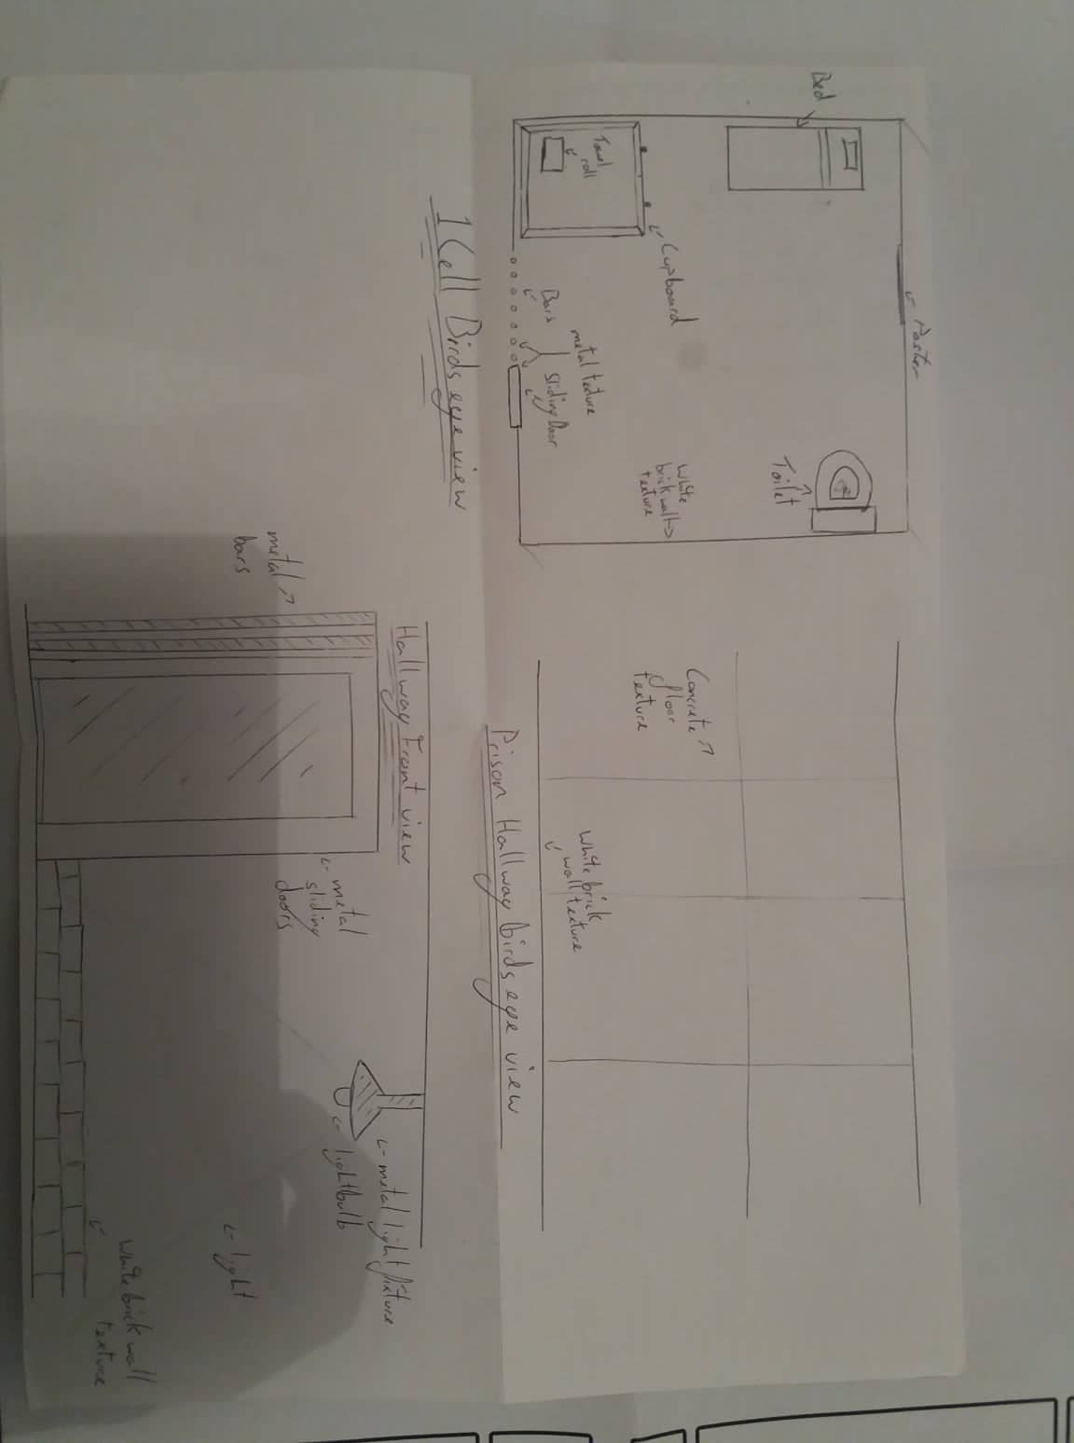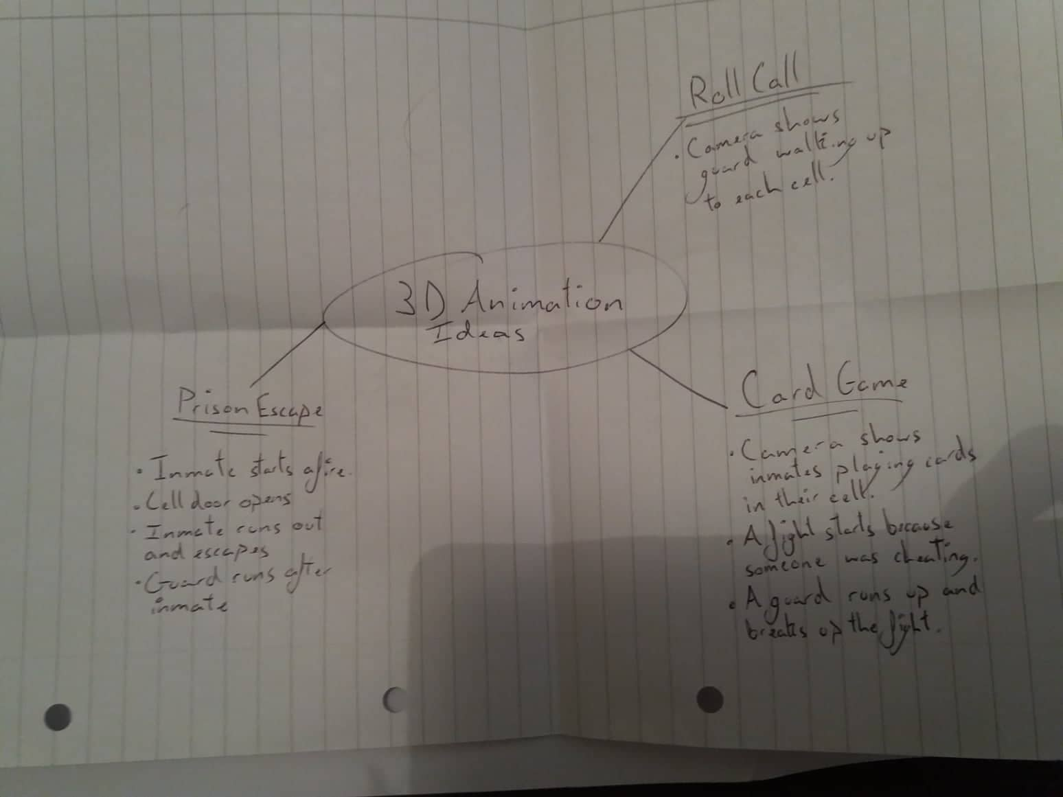

I made a couple of storyboards for my animation but I ended up using the second storyboard I created as I preferred it however I changed it a bit while making my animation as I came up with a couple of new ideas with camera placement to make my scene feel more alive for example in the final animation I have a camera set up like it’s another inmate watching someone from the neighbouring cell escape. I feel like this immerses the viewer more as they are witnessing the escape from a person’s perspective.

## First Storyboard

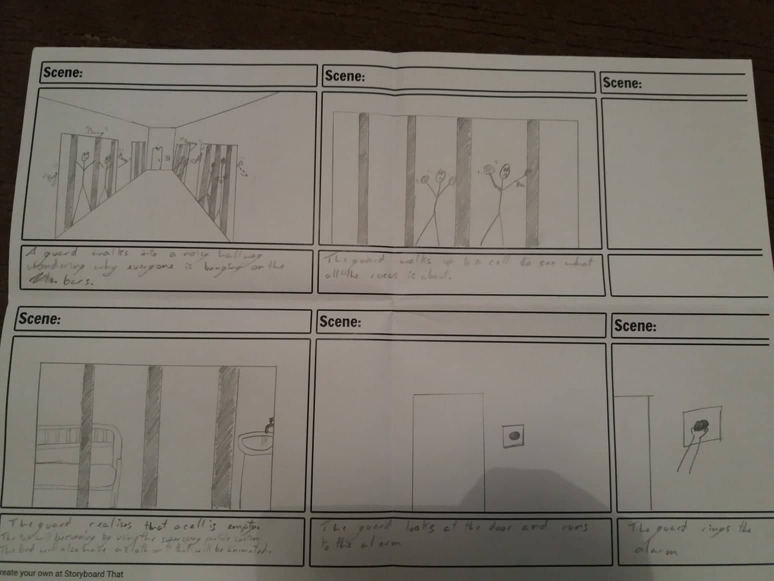

## Second Storyboard

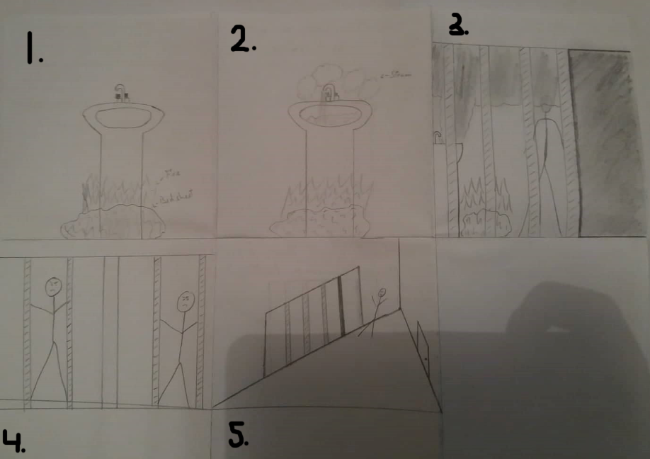

1. Starts with a shot of my 3D modelled sink with a crumpled-up pillow underneath the sink on fire. The fire will heat up the metal bowl on the sink.
2. Then a shot of the tap turning on running hot water onto the heated sink bowl from the fire creating steam.
3. Then a shot of the cell from the outside of the bars. The Steam starts forming covering up the face of the inmate. The cell door then opens and the camera pans to the left.
4. The camera pans to the left to show the other prisoners looking to the left, shouting and banging on the bars.
5. The next shot then uses a different camera looking down the hallway showing the prisoner escaping his cell.

## Third Storyboard

For my final story board, I decided to first practice the drawing on a whiteboard and then did the actual drawing on a full A4 sheet of paper for each slide.

The animation will start off with a shot off the bed on fire to create smoke as seen in my first drawing and then the camera will pan around to a shot of a burning pillow from the bed under a sink with the taps running as seen in my second drawing. The fire from the pillow will heat up the sink turning the water into steam mixing with the fog to create a mask over the inmate’s face in the next drawing showing the inmate escaping out of his cell. The animation will then show him running away. For my last drawing, it shows a guard chasing the inmate down the corridor.

1.

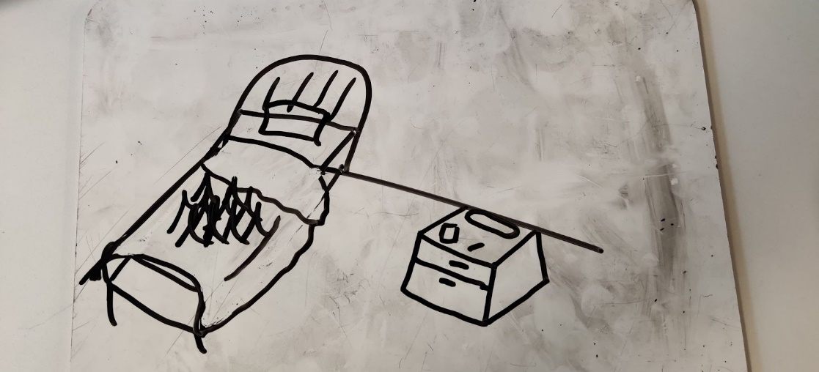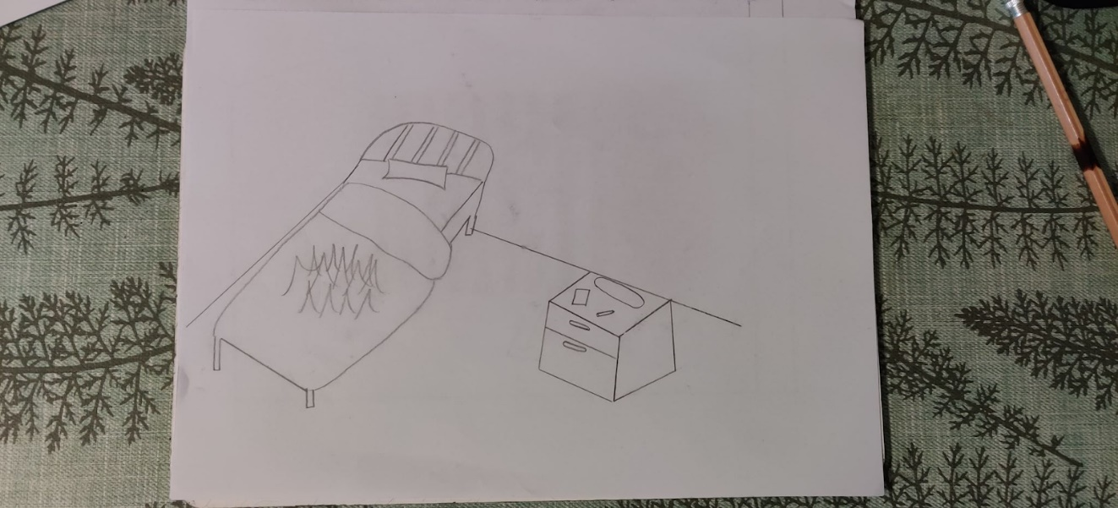

2.

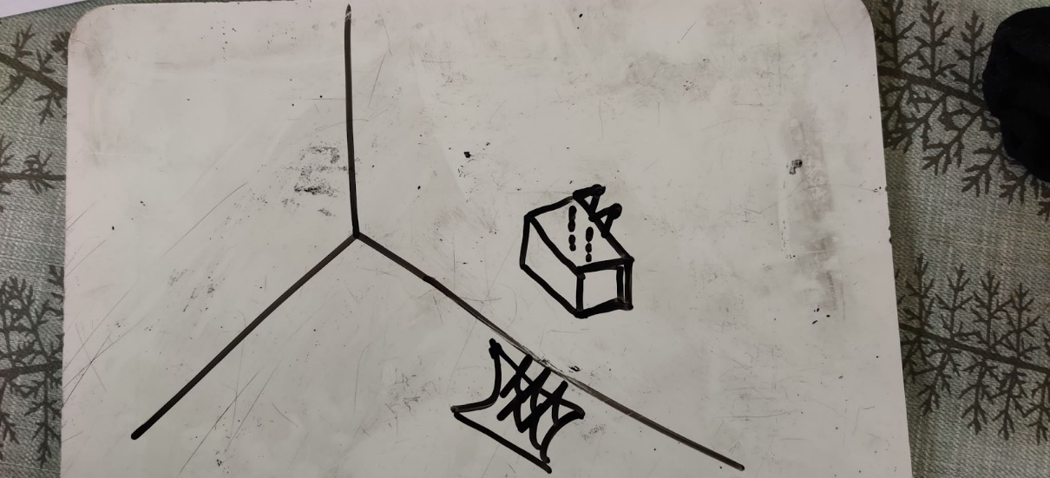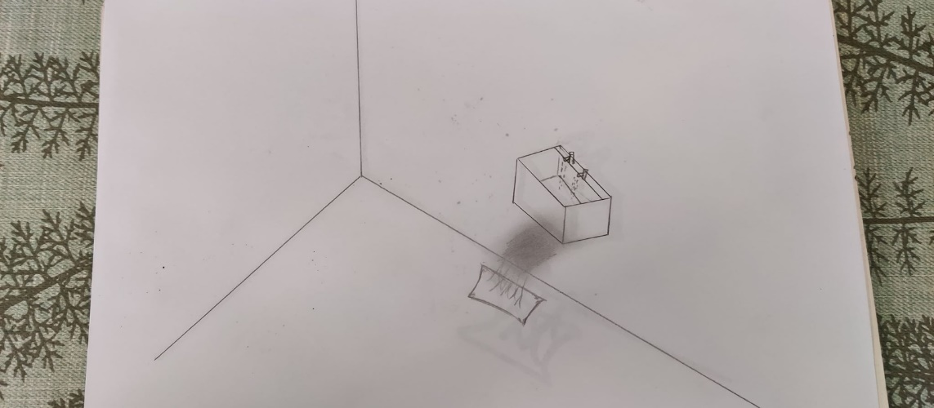

3.

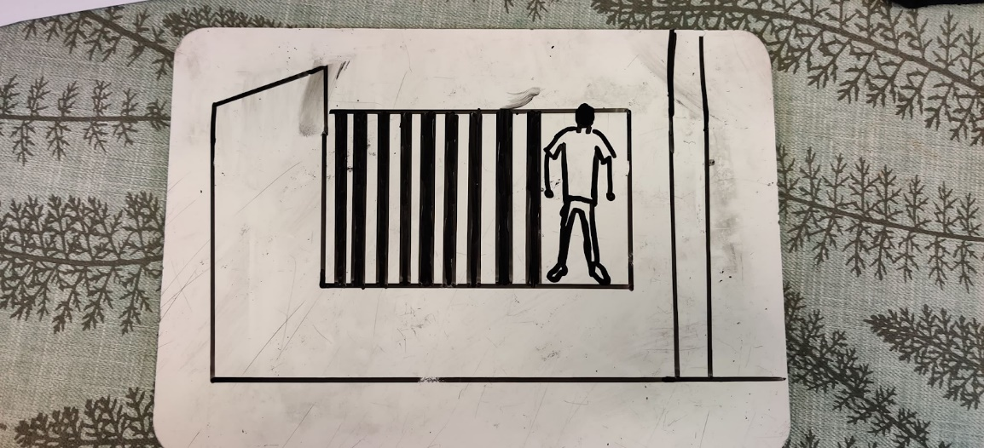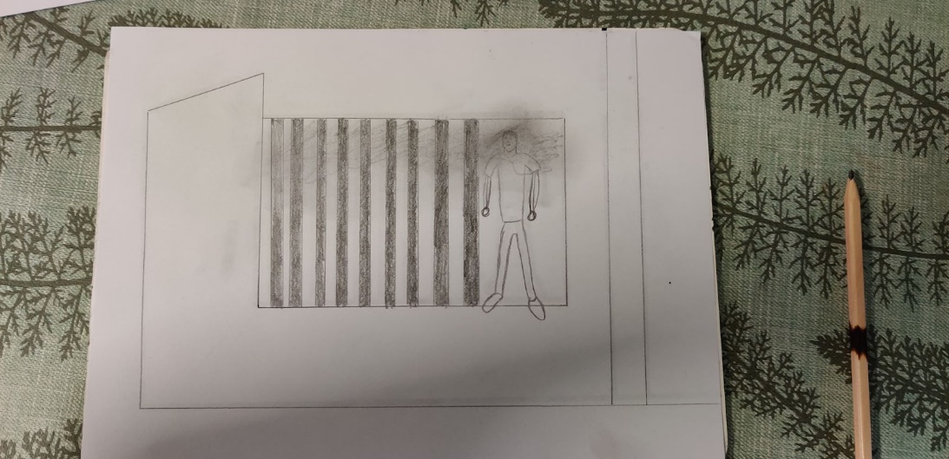

4.

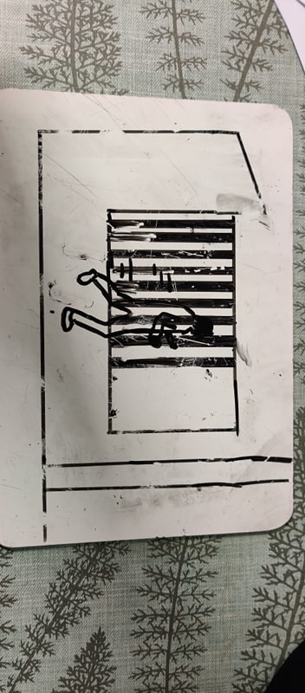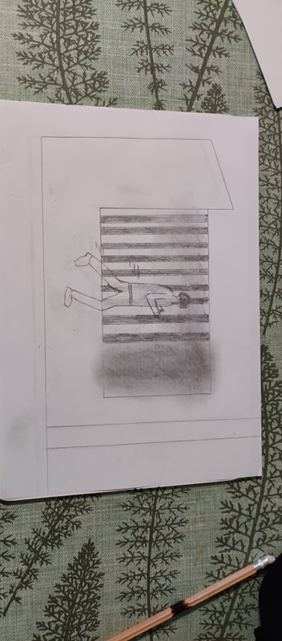

# Mood board

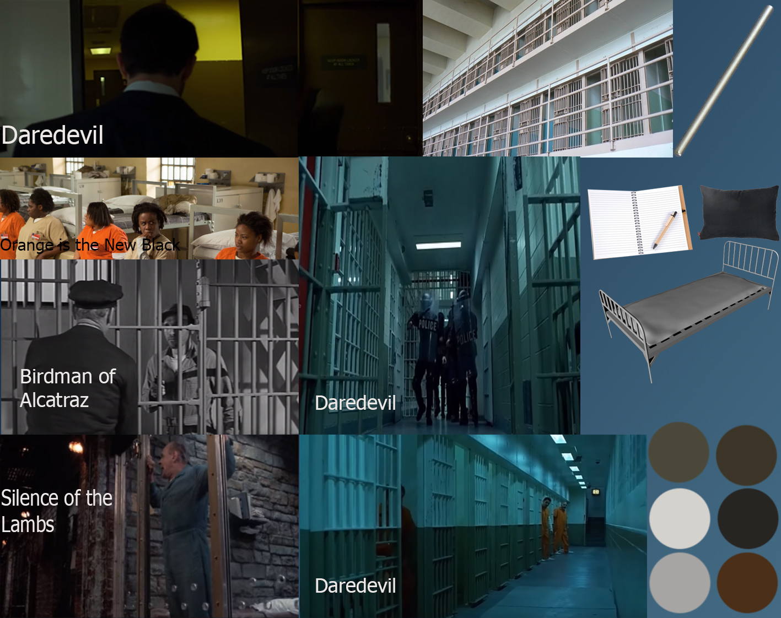

For my mood board I placed a picture from the show orange is the new black in my mood board to remind me of the series and how that prison looked and the items you would find in it for example I didn't know inmates could have pencils, cooking equipment and buy things in an in-house store until I watched the series. Having the picture there made me start thinking about prison which helped for my project. I also used the bright orange clothing on the inmates and had my model wear orange as well. On my mood board I placed a selection of items I would have to model for my environment such as a single bed and a pillow. I also placed these items on my mood board so that every time I looked at them I would think of how I could use or show the models I made in my animation. I wanted my prison to be dim and gloomy therefore I chose dark and dreary colours for my mood board. With a dirty white colour for the walls and ceiling. And then silver for the bars and other metal in the prison. The blacks and dark browns will be used for the floor and the inmate’s personal items. I first thought of making my environment and animation about a prison when I saw daredevil season 3 with the brilliant prison escape seen where daredevil had to fight through countless inmates and guards to escape barely alive because of this I modelled the escape door in my environment (top left picture) to look the same as the door daredevil first walks through to discover countless angry inmates and guards that I believe hints at the future of the escapee in my animation. I placed a screenshot from the movie Silence of the Lambs because I liked the scene where the inmate is left behind and he starts shouting so I decided to have this in my animation with an inmate watching another prisoner escape. I placed a picture from the Birdman of Alcatraz as I like the design of the cell bars and doors so in my animation I will use this as a reference however I will modernise the cell doors by having them slide to open. I took the door design from the daredevil scene. I used the clothing design from orange is the new black making the inmate in my scene wear orange. From Norman of Alcatraz I used the cell door designs but modernized them to make sliding doors. From silence of the lambs I took the idea of an inmate watching someone leave the prison while making comments. From the Daredevil/Punisher scene I took the idea of having a guard chase the inmate down the corridor.

# Target Audience

The target audience for my environment and animation is for people who like the shows and movies referenced in my animation storyboard which are: Daredevil, Punisher, Orange is the New Black, Silence of the Lambs and Birdman of Alcatraz. This is because this is the media that I like and based my animation off. Another reason for this is because I will be judging the animation meaning the animation I make will be something I like to watch such as Daredevil. My environment and animation will both be for all ages as there will be no swearing or violence and sexual references or objects in my environment and animations. There will be no issues with copyright and ethical considerations for my animation and environment as all the models were made by me and I will be using free to use music and sound in my animation. Although this would not matter as this is a student project for educational purposes so I could use copyrighted products. I will also not have to watch out for other ethical considerations such as libel law (damaging someone's reputation) as my animation will be a piece of fiction with nameless characters within it. Discrimination will not be an issue as I will not be targeting any groups in my animation.

# Models

If you would like to know how I made the models for my 3D environment and the environment itself, I have a report illustrating in-depth how each model was made.

[Unit 68 - 3D Envrionments.docx](Unit%2068%20-%203D%20Envrionments.docx)

# Animation

## Fog

To make the fog I went into the helper's bar and selected atmospheric apparatus and then clicked on box gizmo and added one into my scene placing it where I wanted the fog to be. I then hovered my mouse over the rendering selection in the top bar and clicked on environments. I then scrolled down and went to the atmosphere menu and added volume fog. I then selected pick gizmo and selected box gizmo. I then under the volume bar I changed the density value of the fog from 20 to 10 then I changed the noise of the fog to fractal.

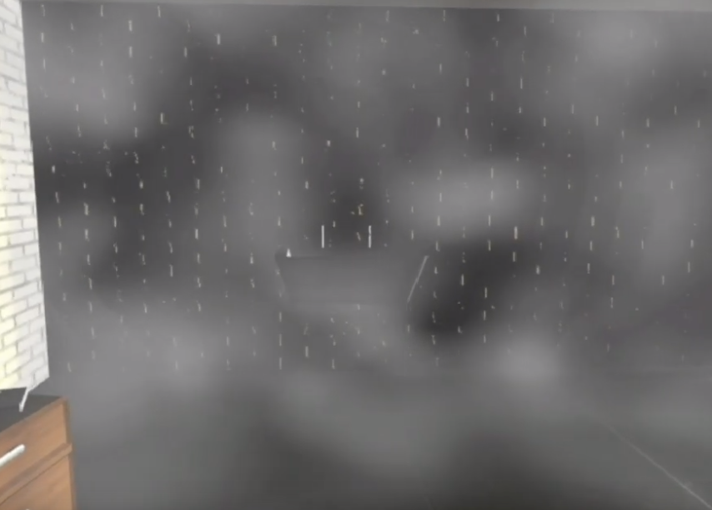

## Fire

To make the fire I went into the helper's bar and selected atmospheric apparatus and then clicked on sphere gizmo and added one into my scene placing it where I wanted the fire to be. I then selected the gizmo and went to atmospheres and effects selected add and clicked on the fire effect advert. I then went into the animation key frames and adjusted the phase and drift values for the fire in later frames of the animation.

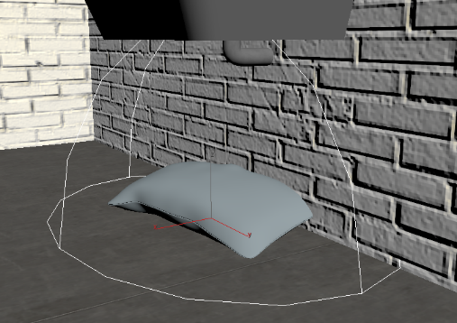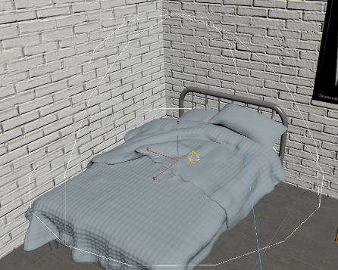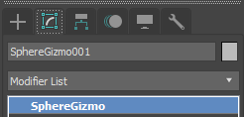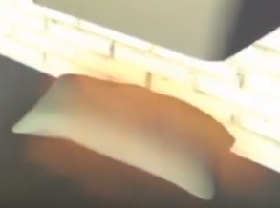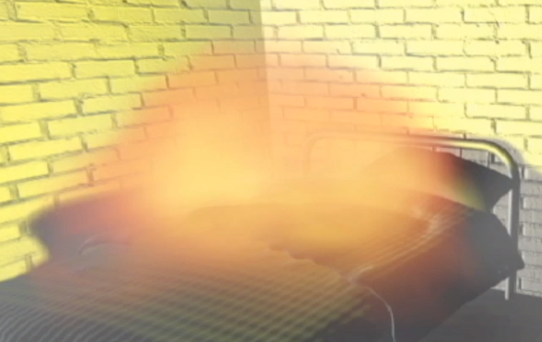

## Super Spray

To animate the tap for my animation I used the Super Spray tool allowing me to control the direction in which the water was going to spray, in my case I had it shoot water downwards. It also allowed me to change the appearance of the water, so I could have it look almost like thick slime or look like an actual running tap. To create the super spray, I went under the add tab and selected Particle Systems from the drop-down menu, I then selected super spray and added it into my scene underneath the tap. I then used the gravity tool faced it downward and used the bind to space warp tool to link the gravity to the super spray system so that the water falls downwards. For the droplets of water, I first created a small cube and applied a blue texture which was a little reflective to it. I then went Under the super spray options to instancing parameters selected pick object and choose the cube that I made, this makes the water look realistic. To stop the water just falling through the sink I used a deflector to make the water droplets bounce a little bit upwards to make it realistic.

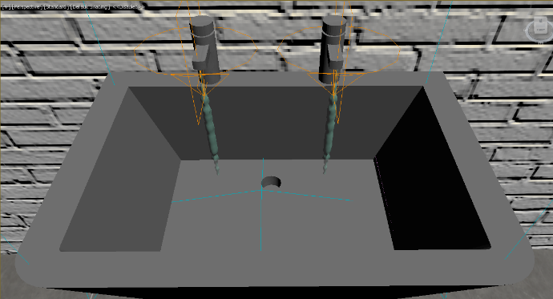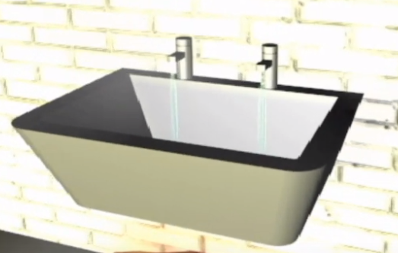

## Skinning a Character

For my animation, I wanted a moveable character in the video. To achieve this, I first found a 3D character model on the internet, downloaded it and placed the model into my scene. Then in 3ds max, I added a biped into my scene under the systems tab. I then moved, rotated and scaled the biped so that it fits into the character model. I then selected the model and added the skin modifier, this added the bones to the model so that it can be animated. I then used the standard walking and running animation provided by 3ds max to move my characters according to my storyboard.

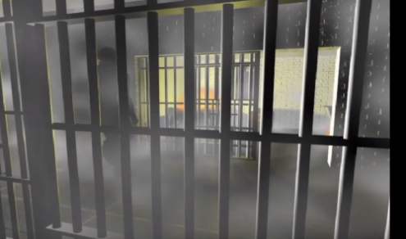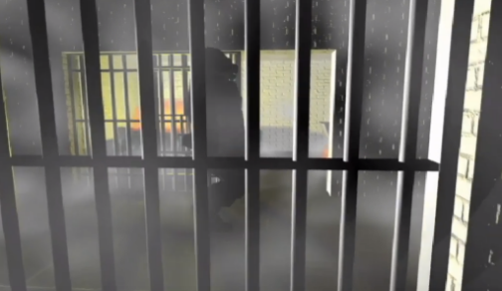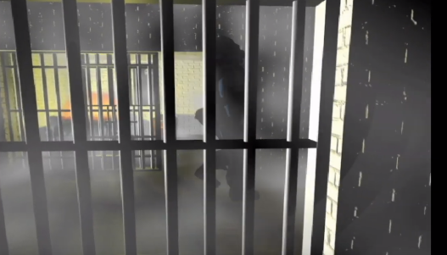

## Cameras

For the cameras, I used the standard 3ds max cameras and placed them where I wanted them to be in my scene. If I wanted to move or rotate the cameras in my scene I would select autokey and select a frame later in my animation and them move or rotate the camera to the desired position and the auto key tool will make a fluid and smooth animation.

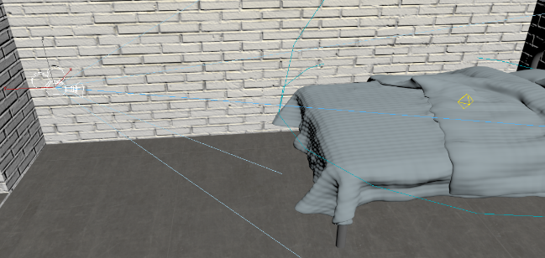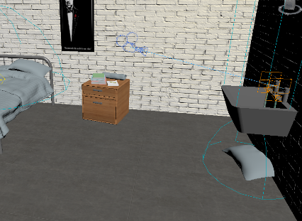

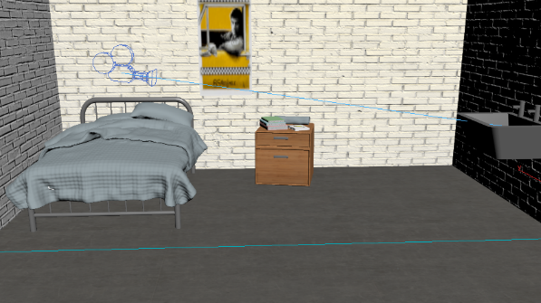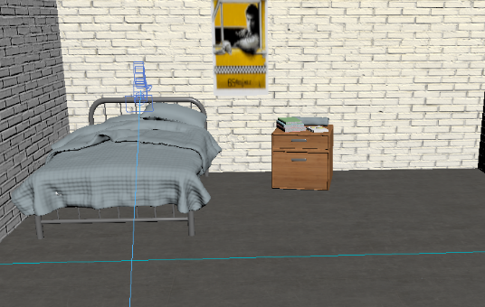

## Sliding Door

For the sliding door, I clicked auto key then moved the frame to one later in the animation for when I wanted the door to open and then selected my door and used the move tool to slide the door forward and then in front of the bars. The auto key filled in the rest and I had a fluid door sliding animation.

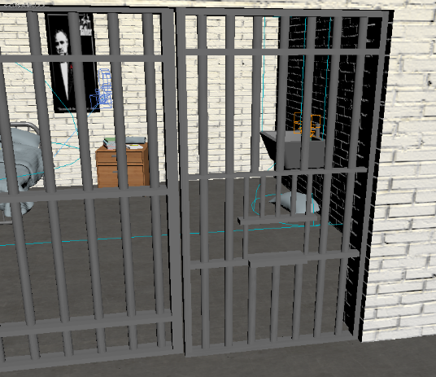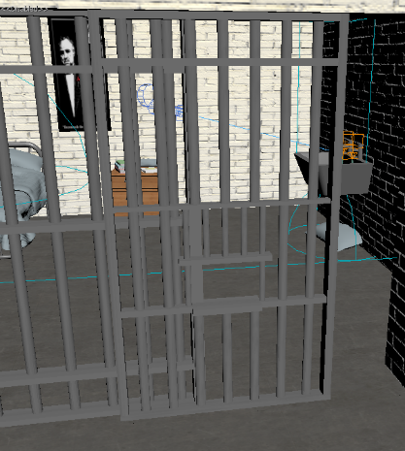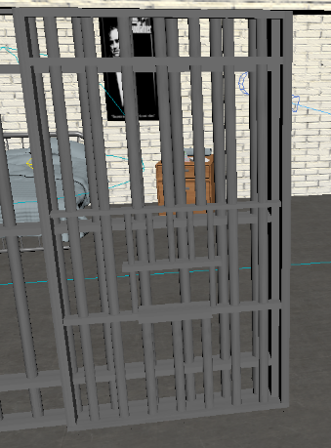

# Reflection

Looking back, I feel like I achieved what I set out to do which is making a prison escape animation using the 3D environment I made for Unit 68 and the different animation techniques I learned in college. If I was to make the animation again I would find a better 3D model for my inmate or even, make one as the model I used off the internet didn’t texture well when imported into 3DS Max. I would also aim to use less particle effects in my animation as my computer’s hardware made it so my animation had to be rendered for multiple days.